## Prerequisites:

1. Minimum 8GB RAM for smooth operation
2. Install Docker Desktop in your computer.
3. **Download Docker Desktop** from the [official website](https://www.docker.com/products/docker-desktop).
4. After installing Docker Desktop, we need to download a docker-compose.yaml file, from drive [docker-compose.yaml](https://drive.google.com/file/d/1r51dnEu6F4PBSIRrihP6xsFwAvWTyVJ3/view?usp=drive_link).
5. Now that we have both files, we need to create our airflow directory. Go to the following path: C:/Users/<your_user>/. Inside of that directory, create a folder called docker and inside of docker create another folder called airflow.
6. Now that we have our airflow folder, we must do the following: a)Create three folders called dags, plugins and logs respectively; b) Move our YAML to that directory.

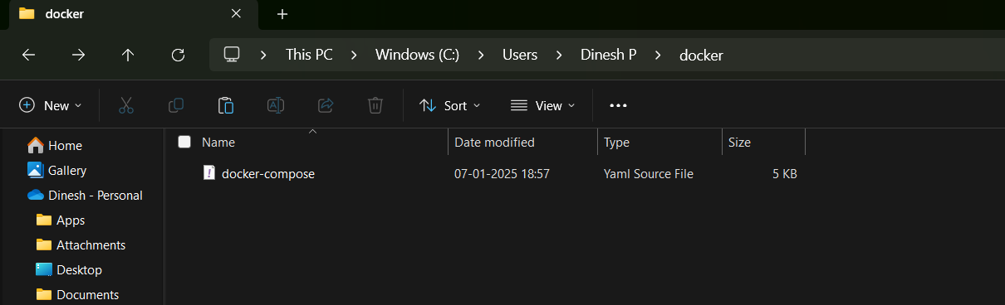

1. Now we are ready to start our instance of Airflow in docker.   
   1st open the docker application then   
   We need to open a PowerShell window and go to the directory above.

Execute below commands

*docker-compose up airflow-init*

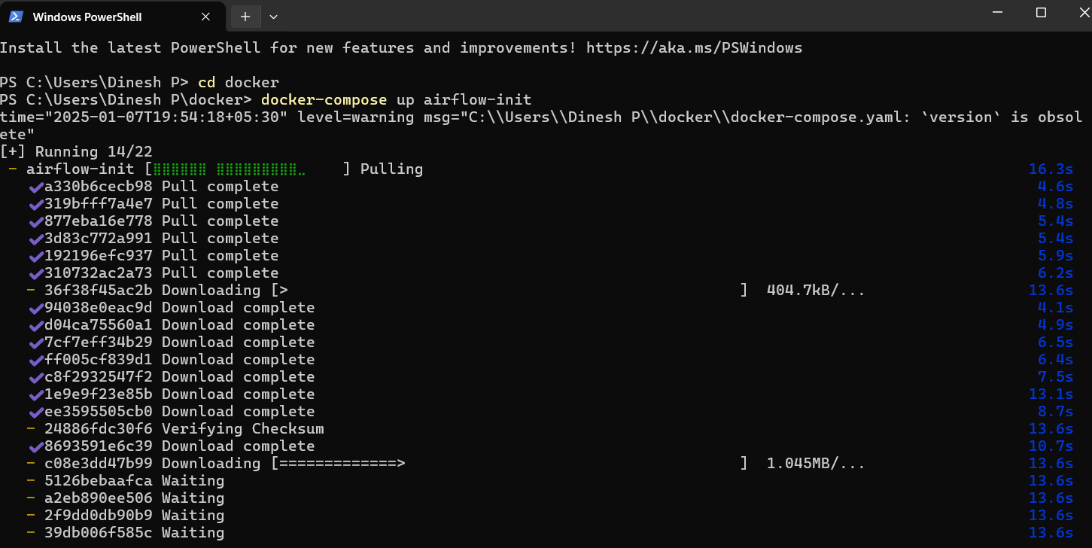

*docker-compose up -d*

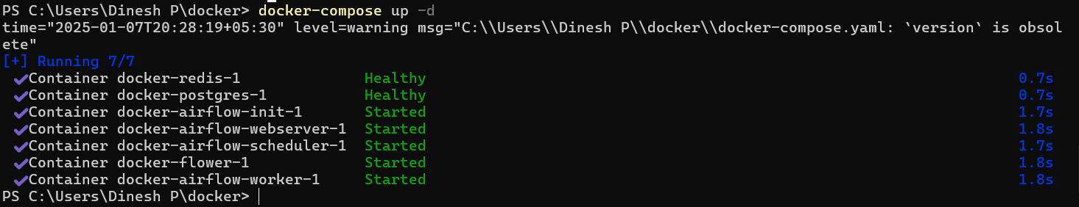

Note: After the second command, a window will keep running some code.

1. After that, we can go to our Docker Desktop app and we will see that a container named airflow was created inside the section Containers/Apps. This container will have 7 sub-containers inside.

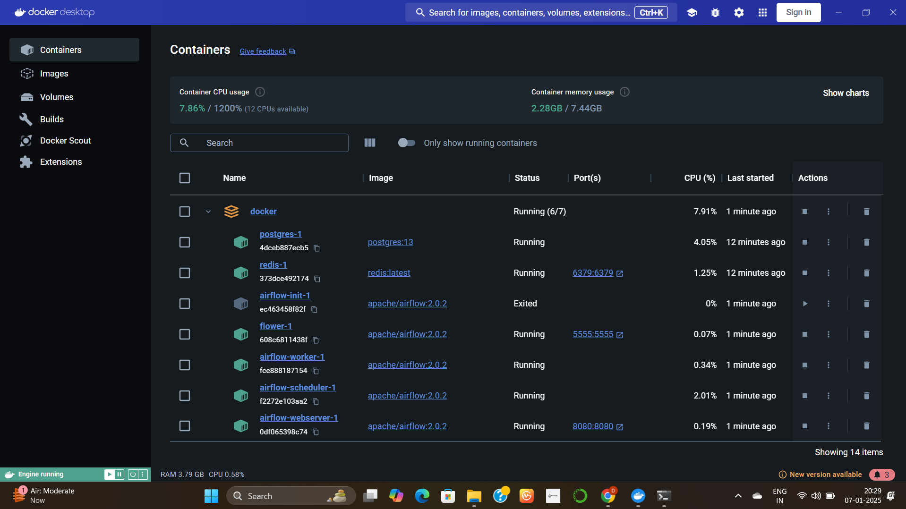

1. Go to localhost:8080, login with below credentials:

user name: airflow

password: airflow

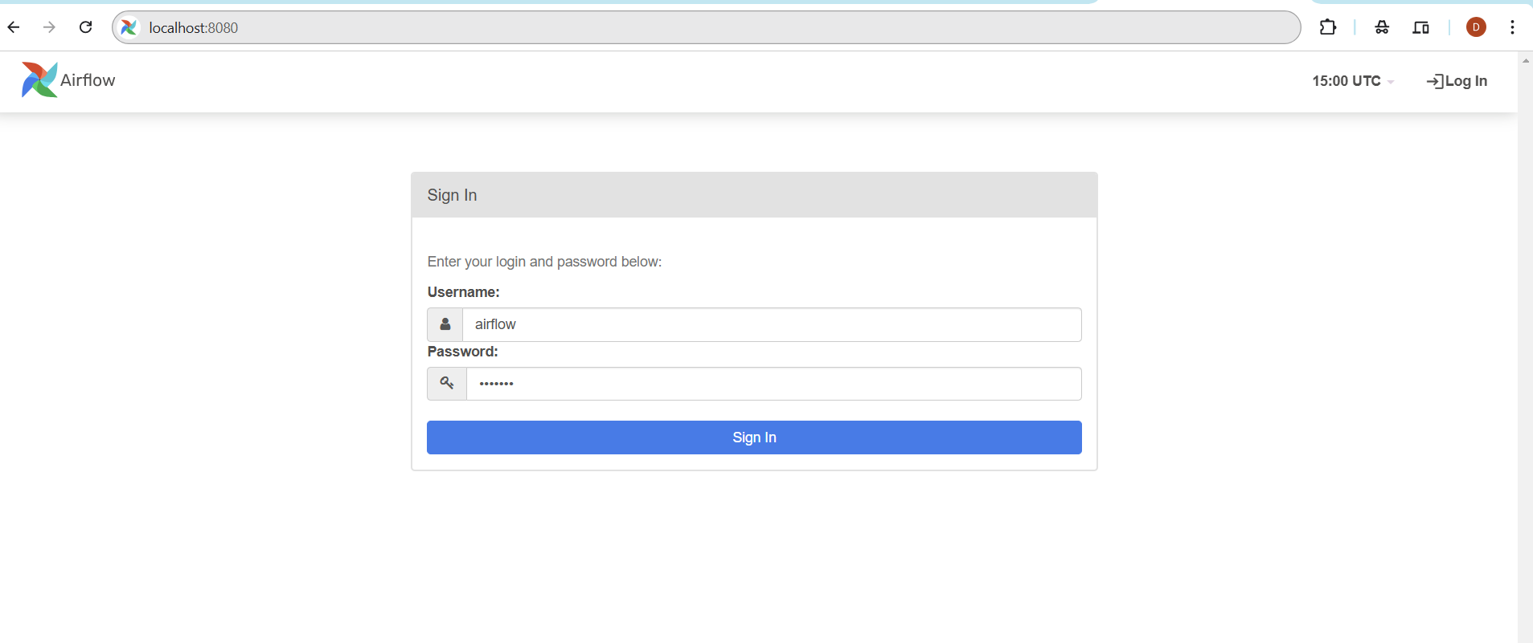

Note: You can put all your DAGs in the dags folder

**To start docker**

docker-compose up -d

**Stop docker**

docker-compose down